INTRODUCTION TO CARBON CYCLING UNITS AND TOOLS

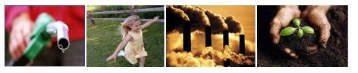

September 2009

Michigan State University

Environmental Literacy Project
http://edr1.educ.msu.edu/EnvironmentalLit/index.htm

Lindsey Mohan, Hui Jin, Li Zhan, and Charles W. Anderson

With help from Liz Ratashak, Cheryl Hach, Daniel Gallagher, Marcia Angle, Russ Stolberg, Sue Zygadlo, Marie Toburen, Jonathon Schramm, and Jennifer Doherty.

Development of these tools was supported by grants from the National Science Foundation: Developing a Research-based Learning Progression for the Role of Carbon in Environmental Systems (REC 0529636), the Center for Curriculum Materials in Science (ESI-0227557), Learning Progression on Carbon-Transforming Processes in Socio-Ecological Systems (NSF 0815993), and Targeted Partnership: Culturally relevant ecology, learning progressions and environmental literacy (NSF-0832173). Any opinions, findings, and conclusions or recommendations expressed in this material are those of the author(s) and do not necessarily reflect the views of the National Science Foundation.
Table of Contents

OVerview of Units 3
Background on Learning Progressions 5
Introduction to tools for reasoning 9
Materials in Tools for reasoning 10
Illustrations of Tools for Reasoning 11
Powers of Ten 11
Matter and Energy 13
Molecular Model Kits 13
Matter and Energy Process Tool 14

OVerview of Units

The carbon cycle strand of the Environmental Literacy Project is interested in students’ reasoning about matter and energy in the context of carbon-transforming processes. At the macroscopic scale the processes include plant and animal growth, animal movement, weight loss, decay, and burning. At the atomic-molecular scale these processes can be identified as photosynthesis, digestion, biosynthesis, cellular respiration, and combustion. We are also interested in how students reason about landscape-scale processes, such as movement of carbon through food webs and between reservoirs, combustion of fossil fuels, and global warming. We want to understand how students can develop deep understandings of these processes as they progress from upper elementary school through college. We know that most students currently do not develop deep understandings of these processes, and we think we have developed some important insights into the nature of students’ difficulties.

Participation

Participation includes some or all of the following activities:
- Getting consent from students, administrator, and/or parents
- Administrating written pre-tests to students
- Arranging for pre-interviews for a sample of students
- Using Systems and Scale unit and some or all of the additional units and tools (described below)
- Administrating written post-tests to students
- Arranging for post-interviews for a sample of students

Units

Most units encompass approximately three to five days of “core activities” focused on important carbon transforming processes. The units also include an additional menu of inquiry, application, and citizenship activities that could be used for additional exploration or extension. The most important feature of these units are the tools for reasoning embedded within the activities—tools to help students reason about matter, energy, and scale. We will ask you to incorporate the tools as much as possible into your teaching across the school year, either by using activities from our menu, or by incorporating the tools into your own activities. The tools are described on the following pages.

We ask that all participating teachers use the systems and scale unit at the beginning of the school year. This unit introduces students to Powers of Ten as a tool for understanding scale, and uses combustion as a way to introduce matter and energy tools. We also ask that teachers use at least 2-3 weeks worth of organism units (plants, animals, decomposers) and/or at least 2-3 weeks of landscape-scale units.

Available units include the following:

1. Systems and Scale Unit: Systems and Scale is a unit that contains 8-9 activities intended to introduce students to using matter, energy and scale. In many ways this unit is a “pre-unit” because it prepares students for using the reasoning tools across the school year. At the beginning of the unit, students complete three activities on Powers of Ten and practice using Powers of Ten as a tool to locate systems on different scales. Students are then introduced to different forms of energy using energy “toys” or “machines” (e.g. solar car, kinetic flashlight, etc). Students use the matter and energy matter and energy process tool to show how energy changes in the toys. Students then think about how energy changes in a candle burning and add matter transformations to the process tool. In middle and high school they look at the atomic-molecular scale and what happens to molecules during combustion (using molecular model kits, burning demonstrations, etc).

2. Organism Units: The organism level units focus on metabolic processes in plants, animals, and decomposers.
- The plant unit uses the matter and energy process tool to help students to trace matter and energy as they learn about photosynthesis (and cell respiration at the middle and high school).
- The animal unit uses the matter and energy process tool to help explain digestion, growth, and movement/weight loss (cell respiration). Students engage in several inquiry-oriented activities to identify key indicators of matter and energy transformations during these processes.
- Likewise, the decomposer unit focuses on decomposer growth and weight loss in decaying materials. In all the units, additional investigation activities and labs are included.
The units also include connections to landscape-scale systems that involve these organisms and citizenship issues, such as deforestation, farming, bio-fuels, food production, diet and climate change, tilling soil, etc.

3. Large Scale Units: There are two units at the landscape-scale.
- The first unit focuses on carbon cycling and locating key reservoirs within the carbon cycle. This unit identifies two main forms of carbon: carbon dioxide and organic carbon. Students trace how these two forms of carbon move between reservoirs and human practices that influence that movement.
- The second unit focuses on the connection between human energy consumption activities and global warming. Students use the process tools to analyze how energy consumption activities including power plants generating electricity, using electrical appliances, transportation, consuming goods and foods, and housing contribute to the increasing carbon concentration in the atmosphere. A new tool—carbon footprint—is also introduced for quantitative measurement.

Background on Learning Progressions

Our work on the Environmental Literacy Project has been to document how students reason about events that occur in natural and human social systems. At the macroscopic scale we document how students account for growth, weight loss, decay and burning and at the large scale we look at their accounts of landscape-scale change and global warming. The goal of our work has been to develop a learning progression that describes how students’ reasoning about matter and energy during these processes develop from upper elementary through high school.

The carbon cycle learning progression describes what we observed from students in the current reality of schools. During the past five years we assessed students’ reasoning about the events listed above, and used the data to develop a learning progression. Our progression includes 4 Levels of Achievements, shown in the Figure below.
Level 4: Processes and Systems Constrained by Principles
Level 3: Chemical Change with Unsuccessful Constraints
Level 1: Force-Dynamic Accounts of Actors and Events
Level 2: Hidden Mechanisms about Events

These levels represent fundamentally different ways students view their world, and should not be treated as a series of levels that could be covered in one unit or even one year. These levels represent very different lenses for looking at the world and ways science can inform what we know and do in that world:
- Level 1 students (at the lower anchor of the learning progression) use force-dynamic reasoning (Pinker, 2007; Talmy, 1988) in which actors (e.g., animals, plants, flames) use enablers (e.g., air, water, food, fuel, sunlight) to fulfill their natural tendencies. Events result from the interplay between the natural tendencies of agents and the balance of forces between enablers that support actors in fulfilling their capacities, and antagonists, which can prevent this from happening. For example, flames burn because they are made to burn; they may need air to burn and water will prevent the flame from doing what it is supposed to do.
- At level 2 students are still guided by force-dynamic reasoning, but can point to hidden mechanisms that move beyond natural tendencies. Students begin to recognize the need to trace materials in and out of systems. Gases are treated more like conditions as opposed to “real matter” and matter and energy are not distinguished.
- At level 3 students begin to recognize chemical changes at an atomic-molecular scale and use chemical identities for several important substances. Some level 3 students attempt to conserve both matter and energy without necessarily knowing great detail about chemical substances and processes. However, most level 3 students still have difficulty with consistently applying conservation principles (i.e., convert matter and energy; ignore gases). Students at this level attempt to develop detailed narratives about relatively common chemical processes, but cannot use these narratives to explain everyday events (they see the narratives as something for science class only).
- At level 4 students see events as “chemically” similar or different in terms of matter and energy and can reason about events in using correct identification of chemical substances and processes. There is an understanding that changes in the world happen in certain ways because systems are constrained by scientific principles (conservation of matter and energy, energy degradation, etc). Level 4 students can also fluidly move between different scales in their reasoning.

Elementary students tend to give Level 1 and 2 accounts. This is also true of middle school students, although 1/5 of middle school students attempt to use what they understand of chemical processes to explain events. High school students generally give Level 2 and 3 accounts, but 10% of high school students show qualitative model-based reasoning (level 4).

It is important to point out that the four levels described above contain both productive and counterproductive progress toward level 4. In fact, the pervasiveness of matter-energy conversions at levels 2 and 3 likely prevent many high school students from achieving level 4.

An important conclusion from our work on the current progression shown in the figure above is the following: When students enter school they use narratives (or stories) to explain how the world works in terms actors fulfilling their intended purposes. This is the students’ natural discourse. The information they learn in science class teaches them more detailed narratives and new vocabulary, and students try to fit the new information into their existing primary discourses. Thus, you might say that students tell the same stories with more details, instead of learning a new way to tell the story from a scientific lens. We believe students need sustained support in learning about and using fundamental scientific principles as one way to support the acquisition and appropriation of scientific discourse at level 4.

We feel confident we captured a way of making sense of the current reality happening in schools. We see patterns in the way students reason and have identified characteristics of this reasoning that may support or prevent progress toward scientific reasoning. For this reason, we have hypothesized that an alternative pathway may exist—one that would capitalize on productive characteristics of students’ reasoning at levels 1, 2, and 3 and would be more successful in helping students achieve level 4 by the end of high school. This pathway would foreground scientific principles, starting in upper elementary classrooms. In this way, accounting for matter, energy, and scale would become routine parts of explaining events in the world. The figure below shows the proposed alternative pathway (laid out with dashed lines). The new pathway specifies different levels 2 and 3—ones that focus on principles-first. This alternative pathway has important implications for the goals we have in our teaching experiments and the means for achieving those goals.
Level 3: Chemical Change with Unsuccessful Constraints
Level 1: Force-Dynamic Accounts of Actors and Events
Level 2: Hidden Mechanisms about Events
Level 2: Successful Conservation at Macroscopic Scale
Level 3: Principled Accounts at Molecular Scale without Chemical Details
Pathway: Details-First focusing on Naming
Pathway: Principles-First focusing on Explaining
Level 4: Processes and Systems Constrained by Principles

At level 2, instead of focusing on identifying hidden mechanisms that cause events to happen, students would focus on identifying experiences that help them make sense of changes in matter and energy during those events (breathing in and out, sweating, seeing smoke, feeling heat or temperature change, seeing light or motion, etc).

At level 3, instead of learning detailed narratives (step-by-step) for individual chemical processes, students would focus on accounting for matter and energy inputs and outputs and use that information to make comparisons between different chemical processes.

We used the NEW levels 2 and 3 to help us set goals for elementary, middle and high school. See table below:

Level | Enablers or Inputs | Actors and Settings or Systems | Results: Purposes or Products
Level 1. Lower Anchor, elementary starting point | Needs or enablers | Abilities or powers of actors  Settings for events | Achieving purposes or goals of actors
Principle-based Level 2. Elementary goal | Different kinds of enablers:  --materials (solid, liquid, gas)  --energy sources  --conditions | Abilities of actors plus internal structure (organs, cells) and movement of materials and energy through settings and actors | Material products  --gas-gas cycles  --growth as matter moving into bodies  Energy products
Principle-based Level 3. Middle school goal | Material inputs, distinguishing organic from inorganic materials  Forms of energy, including chemical energy (C-C and C-H bonds) | Movement of materials through systems at multiple scales  Living systems made of organic materials | Changes in matter obeying conservation laws  Transformation and degradation of energy
Level 4. Upper Anchor, high school goal | Material inputs with specific chemical identities  Energy inputs | Movement of atoms in molecules through systems at atomic-molecular to large scale socio-ecological systems | Material products tracing atoms between inorganic and organic forms  Transformation and degradation of energy

Elementary Goal: The starting point for most elementary students is level 1 or “old” level 2. The goal for elementary teaching experiments is to support students in achieving the “new” level 2. The new level 2 focuses on macroscopic conservation of matter and energy—in particular helping students see that gases are matter and energy is not, and changes in matter and energy have macroscopic indicators even if these changes really happen at scales not visible to the human eye.

Middle Goal: Middle school students span from level 1 to old levels 2 and 3. A goal from middle school students is to support them in using principles to constrain their reasoning about chemical processes. Students at this age level do not need to know all the chemical details and cell structures involved in these processes, but they do need to have a commitment to tracing matter and energy through processes (and keeping the two separate).

High Goal: High school students generally understand the world in terms of old levels 2 and 3. Many have learned detailed stories about the most common chemical processes they encounter in science class, however, when asked to apply this information to explain real-world events, they struggle to connect the two, often using energy as a “fudge-factor” to explain what happens during solid-gas transformation. A goal for high school students is to use matter and energy conservation at the atomic-molecular scale, identifying the most important substances going in and out of systems, understanding the nature of these substances, and developing an energy storyline that parallels the matter storyline and respects energy conservation and degradation.

Introduction to tools for reasoning

Scientists understand the world by creating models that explain in terms of hidden mechanisms—things that are too small or too large to observe such as atoms, molecules, and the solar system, or changes that happen in a very long time such as global warming or very short time such as momentum. The models are constrained by scientific principles such as Newton’s laws and laws of thermodynamics. A big problem with the scientific models is that the models are usually complex and contain many details, which makes it very difficult for students to understand. Our tools for reasoning simplify the scientific models and make the principles—matter conservation, energy conservation, and energy degradation—visible for students.

We found that students tend to explain macroscopic environmental processes in terms of force-dynamic reasoning—how “the actor” uses “its enablers”. This reasoning is very different from the scientific model-based reasoning, which link the macroscopic processes to the atomic-molecular and landscape models with matter and energy as constraints. Our curriculum introduces a set of tools to facilitate students’ transition from the force-dynamic reasoning to the scientific model-based reasoning. These tools were designed for teaching at elementary, middle, and high school levels focusing on carbon-transforming processes in socio-ecological systems at multiple scales, including cellular and organismal metabolism, ecosystem energetics and carbon cycling, carbon sequestration, and combustion of fossil fuels. These processes: (a) create organic carbon (photosynthesis), (b) transform organic carbon (biosynthesis, digestion, food webs, carbon sequestration), and (c) oxidize organic carbon (cellular respiration, combustion). The primary cause of global climate change is the current worldwide imbalance among these processes.

The teaching goal is to support students as they move through a learning progression leading to environmental science literacy—the capacity to understand and participate in evidence-based discussions of socio-ecological systems and to make informed decisions about appropriate actions and policies. As discussed in more detail in the Appendix, our research shows that in order to develop environmental science literacy, students must master three key principles: scale, matter, and energy. The tools for reasoning are designed to embody those principles.
- The Powers of 10 Tool embodies the principle of scale. Students can use this tool to connect representations of systems and processes at multiple scales: atomic-molecular, microscopic, macroscopic, and landscape scales.
- Matter and energy process tool embodies using three matter/energy principles—matter conservation, energy conservation, and energy degradation. In particular, it helps students to conserve matter separately from energy and conserve energy with degradation:
  - The top row of the tool (wavy arrows) embodies conservation and degradation of energy: Students can use this part of the tool to describe how any process involving chemical and/or physical change transforms energy without changing the total amount of energy, but always releases waste heat.
  - The second row of the tool (straight arrows) embodies conservation of matter. Younger students can use this tool to identify solids, liquids, and gases as reactants and products. More advanced students can use the tool more rigorously to balance mass of reactants and products and to trace atoms through processes.
  - In the landscape-scale units, students are also expected to use matter (straight) arrows and energy (wavy) arrows to connect multiple processes in socio-ecological systems. This will help students to link the atomic-molecular processes and macroscopic processes with the landscape processes.
- Molecular models embody conservation of matter. Students can use this tool to model how all carbon-transforming processes rearrange atoms into new molecules without creating or destroying atoms. This tool will help students to trace matter when using the process tool.

We have designed these Tools for Reasoning to be flexible enough to use in every lesson, including both lessons in our teaching modules and other lessons involving carbon-transforming processes

All teaching materials are available on the environmental literacy website at http://edr1.educ.msu.edu/EnvironmentalLit/publicsite/html/cc_tm.html.

Materials in Tools for reasoning

PowerPoint slides
- Powers of 10 introduction: The one-meter square
- Tools for Reasoning Slides
  - Blank Matter and energy process tool slide
  - Blank Powers of 10 slide
  - Additional Powers of 10 slides
    - Illustrated Powers of 10 slide
    - Partially illustrated Powers of 10 slide
  - Additional Matter and energy process tool slides
    - Combustion of methane, macroscopic scale
    - Combustion of methane, atomic-molecular scale
    - Plant growth, macroscopic scale
    - Photosynthesis, atomic-molecular scale
    - Animal movement and weight loss, macroscopic scale
    - Decay, macroscopic scale
    - Cellular respiration, atomic-molecular scale
    - Animal growth, macroscopic scale
    - Digestion in animals, atomic-molecular scale
    - Biosynthesis in animals, atomic-molecular scale

Student handouts and worksheets
- Powers of 10 handouts
  - Illustrated Powers of 10 handout
  - Partially illustrated Powers of 10 handout
  - Blank Powers of 10 handout
- Blank Matter and energy process tool handout

Wall charts
- Powers of 10 wall charts
  - Illustrated Powers of 10 wall chart
  - Partially illustrated Powers of 10 wall chart
  - Blank Powers of 10 wall chart
- Matter and energy process tool wall chart
  - Matter and energy process tool wall chart
  - Matter, energy, and scale symbols (to be attached to wall chart)
  - Illustration of processes (to be attached to wall chart)

Molecular model kits
- Teacher kit: 24 hydrogen, 36 oxygen, 6 carbon, 24 nitrogen, and 80 springs.
- Student kit for groups of 3 students: 12 hydrogen, 18 oxygen, 6 carbon, 2 nitrogen, and 36-40 springs.

Illustrations of Tools for Reasoning

Powers of Ten

Wall Chart
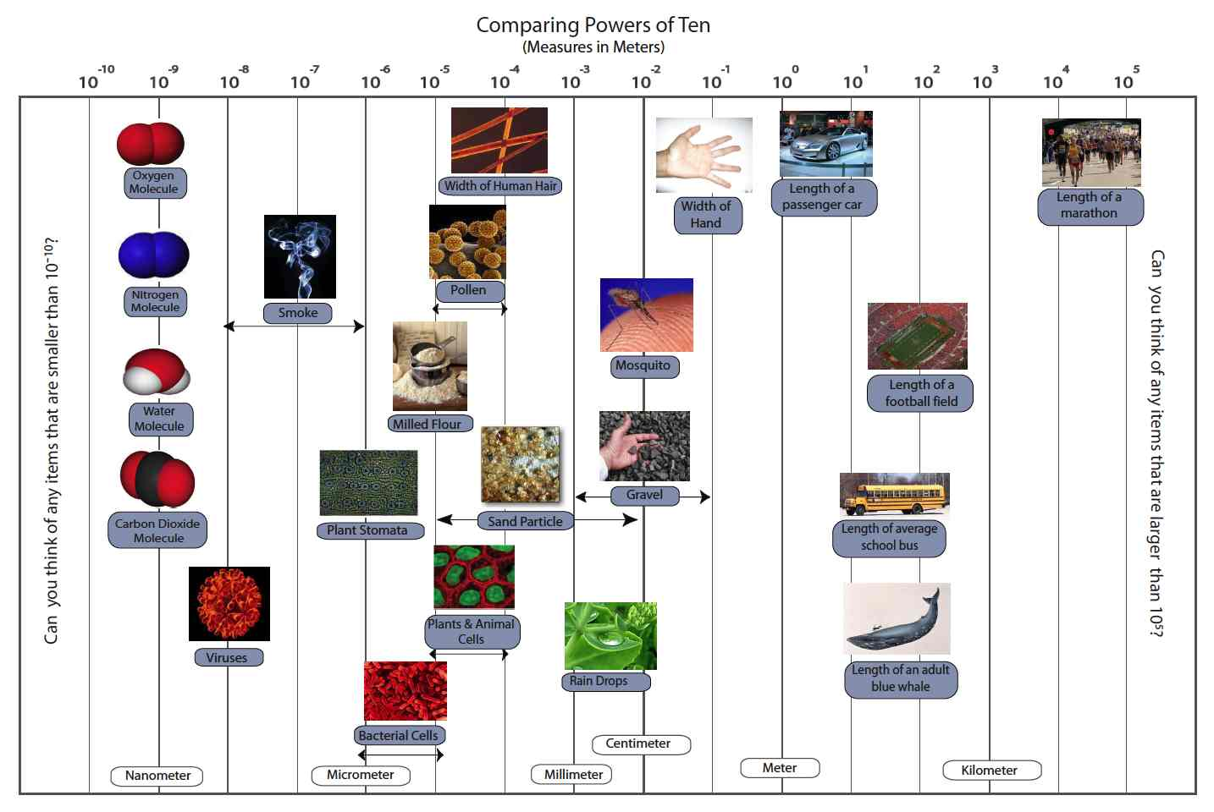

PowerPoint Slides

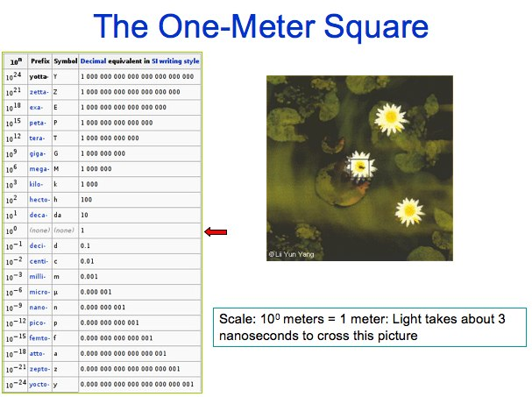

Matter and Energy

Molecular Model Kits

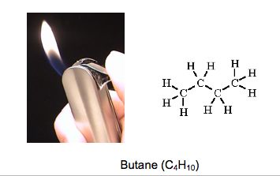
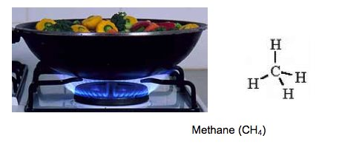
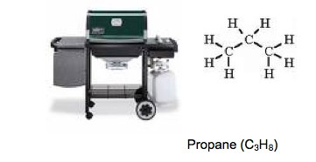
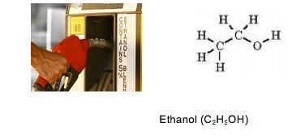
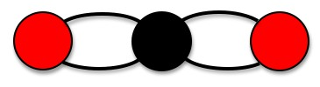
WATER MOLECULE

Matter and Energy Process Tool


